www.eng.uwo.ca/people/.../study%20note%20on%20dynamics.doc
Self-study notes - BASIC DYNAMICS OF STRUCTURES AND VORTEX SHEDDING

This note are intended as a reminder of a simple method for determining the natural frequency in bending of a structure so that a check can be made to see whether this frequency coincides with that of any imposed dynamic load, particularly that caused by vortex shedding as a result of wind action.

We shall not consider damping here and so shall not assess the amplitude of any resulting excitation.

The method makes the reasonable and very practical assumption that any deflections of a structure are proportional to the applied force. Thus, the structural members may be considered to be springs.

In accordance with Newton’s law of motion, the equation F = m.a states that if the structure carries a mass (m) its acceleration (a) is proportional to the applied force (F).

By considering simple harmonic motion behaviour of the structure the basic equation required for assessment of natural frequencies is
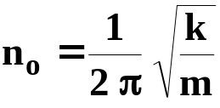

where n_{o} = frequency of vibration (cycles per second or Hz)
k = elastic stiffness of the spring system supporting the mass (N/m)
m = mass undergoing vibration (kg)

So, we require information regarding the stiffness and mass of the system in order to determine the natural frequency. Note that the correct units for force, mass and length are N, kg and m, respectively, for this equation to give the frequency in c/s or Hz.

As a simple example, consider a mass of 1.5kg suspended from a spring of stiffness 7N/mm.
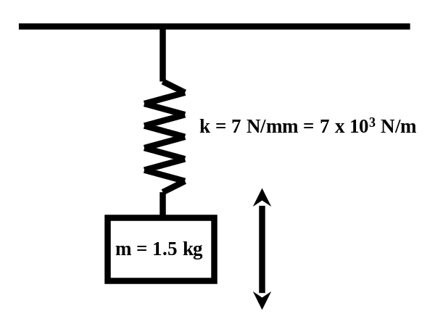
Hence,
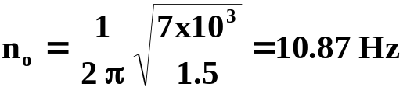
Consider a simply-supported bridge loaded at the quarter point by a vehicle of 10t (10,000kg). If the deflection at the loaded point has been either computed or measured to be 1.5mm under a load of 1kN, then we can compute the natural frequency.
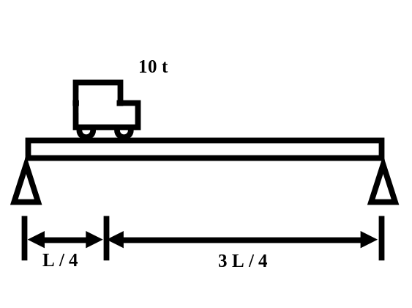
Ignoring the self-weight of the bridge, for simplification, we have spring stiffness (k) as
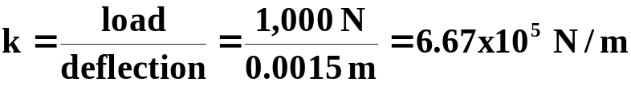
Mass vibrated is m = 10,000 kg so that
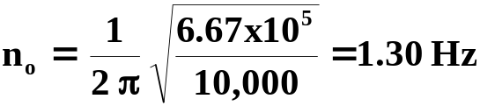

Suppose we have a cantilever of length L with a load F at the end which causes a deflection (δ) at that point.
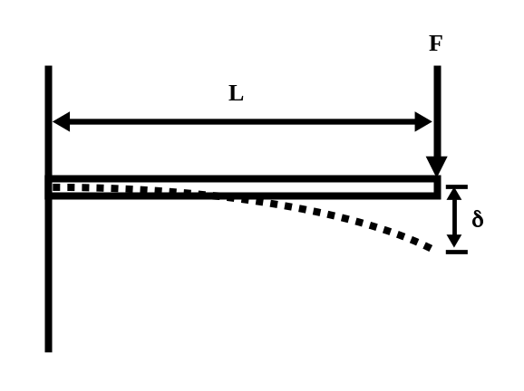
We know from simple beam bending theory that the end deflection for this configuration is given by
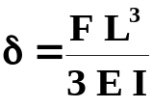
where E is the modulus of elasticity and I is the second moment of area of the section. Hence, the stiffness k is given by
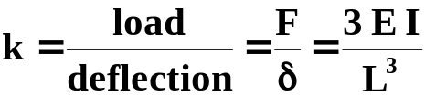
So, our basic equation for natural frequency becomes
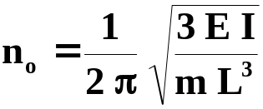

In practice, a structure (such as the bridge and cantilever we’ve just looked at) will have self-weight and this will affect the natural frequency. Before considering such a distributed self-mass we will look at a structural member consisting of two point masses (m₁ and m₂). Now we have two Newton’s equations instead of one

F₁ = m₁ a₁ and F₂ = m₂ a₂

There are now two natural frequencies, each resulting from the coupled effect of m₁ and m₂ and the stiffness of the structure. This is because each mass added to the structure must add one degree-of-freedom to the deflected shape. Consider a cantilever with two masses, m₁ and m₂
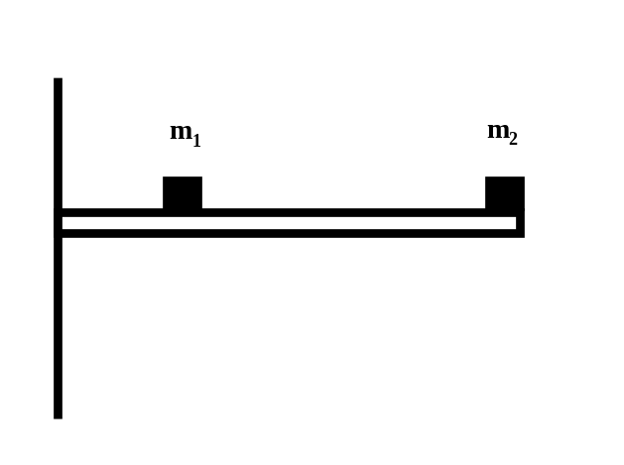

Below are two possible deflected shapes in which the masses deflect either in the same or in the opposite directions, respectively.

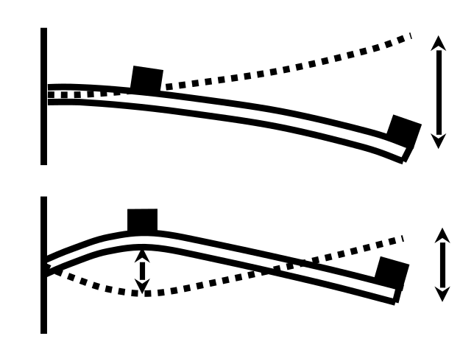

The stiffness of the cantilever in the 2 modes must be different because the curvatures of the member are different in the two cases. Hence, two distinct frequencies arise from application of the basic natural frequency equation.

In structures it is usually (although not always) the lowest frequency that is of greatest concern because it is the one most likely to be associated with applied wind forcing (and also wave forcing).

How can we determine the natural frequency of a structure with a uniformly distributed self-mass? This can be done by considering, for example, our cantilever with two point masses, one being a mass m₁ at a distance x from the support (A) and the second an equivalent end mass m _{e}. It is equivalent in the sense that it is the value of the end mass that causes the same frequency of vibration as m₁.

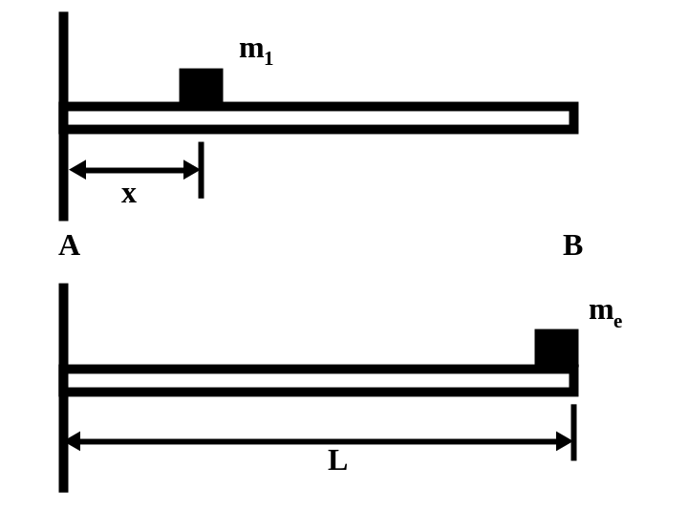

The cantilever itself is still considered mass-less. We saw earlier that the frequency of a cantilever with a point load at the end was given by
For the mass m₁ the part of the cantilever beyond the mass can be ignored since it is mass-less. Hence
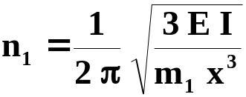
For the end mass, m_{e}, we have
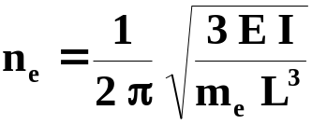
If these two frequencies are to be equal then
m₁ x³ = m_{e} L³
or
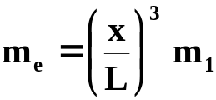
The self-mass of the cantilever can now be dealt with by applying a uniformly distributed mass of value m per metre along the entire length (AB). Consider a small element of length dx situated a distance x from A. Its mass is m.dx and the part of the end mass equivalent to this element is
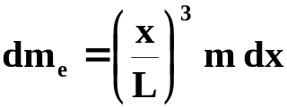
By integrating along the whole length we have
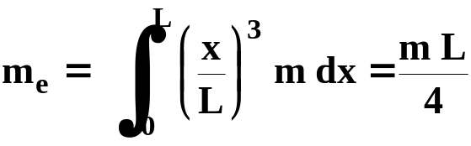

Hence, a cantilever with a self-mass uniformly distributed along its length would vibrate at the same frequency as a mass-less cantilever loaded at the end with a mass equal to ¼ of its actual self-mass.
As an example, a cantilever has a length of 4m and a flexural rigidity (EI) of 6.75x10⁷ kNmm². It carries a mass of 500kg at its centre and has a uniformly distributed self mass of 1,200kg. What is the natural frequency of the structure?

First, we need to compute the total equivalent end point mass and put this into the natural frequency equation for a cantilever

m_{e} = (equivalent end mass for 500 kg x/L = ½) + (equivalent end mass for 1,200 kg distributed self mass)

m_{e} = 500 . (2/4)³ + ¼ . 1200 = 362.5 kg

EI = (6.75 x 10⁷) x 10³ x 10⁻⁶ = 6.75 x 10⁴ Nm²

Hence,
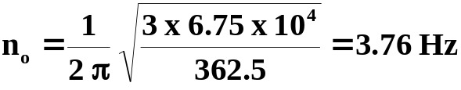

The natural frequencies we have computed so far are the undamped natural frequencies that assume that there is no structural damping. In most practical cases the damped natural frequency is very close to the undamped natural frequency and so the values we have computed may be applied to the equivalent damped structure.

The methods we have looked at here may be applied to more complex structures, such as simply supported beams and frame buildings. However, these shall not be covered in this introductory note.

The wind excitation of a structure takes many forms (see lecture notes) but one simple case of relevance to cantilevers and tower structures is vortex shedding excitation. The frequency of such excitation is given by
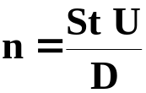

where St is the Strouhal number for the structure, U is the wind speed and D is the breadth of the structure normal to the wind direction. When n = n_{o} significant oscillation of the structure may occur.

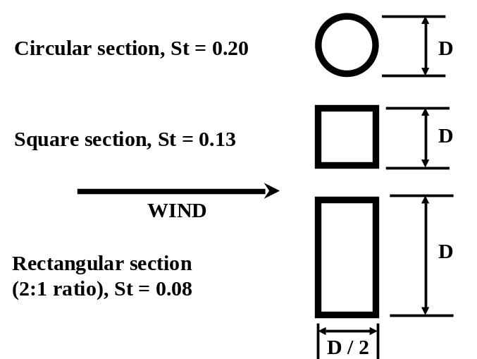

Questions

- A lighting column is 12 m high (H) and constructed from hollow circular steel tube of 140 mm outside diameter with a wall thickness of 3mm. The lamp at the top has a mass of 7.5 kg. Calculate
(a) the natural frequency of the lighting column
(b) the critical wind speed for the onset of vortex-shedding induced vibrations
Take the density of steel ρ = 7850 kg/m³ and the modulus of elasticity E = 205 x10⁹ N/m².
[Answers: (a) 0.85 Hz, (b) 0.6 m/s. It is interesting to note that actual measurements on a full-scale lighting column under the action of the wind, with the same parameters as in this question, by Dr Roger Hoxey at the Silsoe Research Institute in the UK produced a value of 0.89 Hz for the natural frequency]

- A 2m long circular section aluminium member of 80 mm outside diameter and a wall thickness of 3 mm is attached to the wall of a building so that it projects outwards horizontally. A security camera system weighing 10kg is to be attached to the free end of the cantilever. Calculate
(a) the natural frequency of the cantilever alone
(b) the critical wind speed for the onset of vortex-shedding induced vibrations
(c) the same parameters in (a) and (b) after the camera has been installed
Take the density of aluminium ρ = 2720 kg/m³ and modulus of elasticity E = 68.9x10⁹ N/m².
[Answers: (a) 18.9 Hz, (b) 7.56 m/s, (c) 5.7 Hz, 2.28 m/s]

- The structural frame shown below is rigid jointed and fixed to its supports. The mass of the structure is 5000 kg and is concentrated on the beam that is assumed to be rigid. The two columns are assumed to be mass-less and each has a flexural stiffness (EI) of 4.5x10⁶ Nm². If the structure has a damping ratio (ζ) of 4% (=0.04), calculate; (a) the undamped natural frequency and (b) the damped natural frequency. To solve this problem you will need to look at a structures text book or use elementary bending theory to find the forces corresponding to a unit lateral displacement for rigid end members with zero rotation at the top and bottom. This will give the bending stiffness for using in the natural frequency equation. To compute the damped natural frequency please look at the equation on page 2 of the lecture class notes.
[Answers: (a) 4.502 Hz, (b) 4.498 Hz]

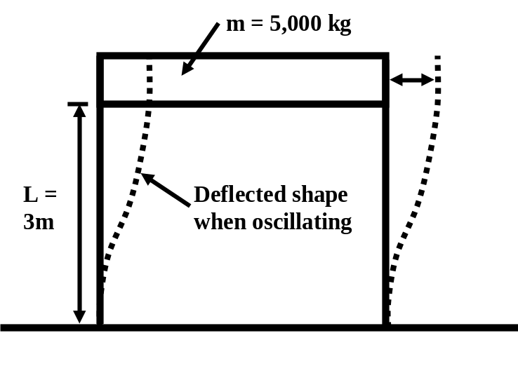

- So far we have focused on cantilever and tower structures. But what do we do for simply supported beam structures, like bridge decks, for example? We apply the same kind of analysis as for the cantilever except that, instead of trying to find an equivalent end mass for the distributed self-mass of the beam, we try to obtain an equivalent centre mass (m_{e}).
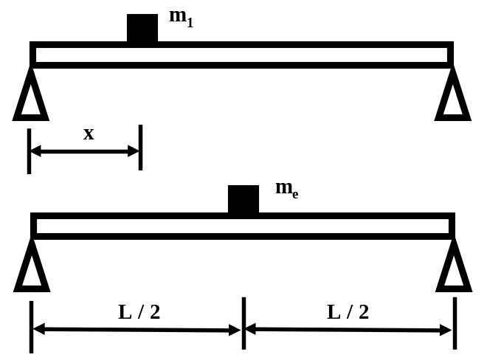

We need to know the stiffness of the beam when loaded by a point mass m₁ a distance x from one of the supports. From a structures text book we can find the expression for the deflection (δ) under a load (F) which is
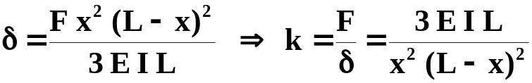

To obtain the central stiffness for m_{e} the distance x is made equal to ½L in this expression that gives the well known value of 48EI/L³. The natural frequencies for the two masses must be the same and so using our basic natural frequency equation, in the same way as we did for the cantilever, we can equate
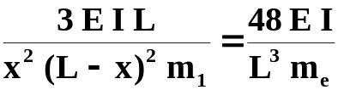
so that
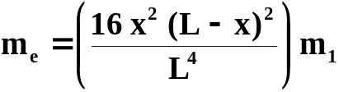

To calculate the equivalent centre-mass corresponding to a uniformly distributed mass of m (kg) per metre length we integrate along the span, as before
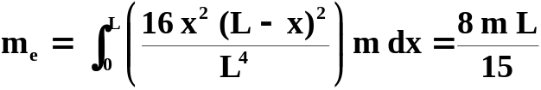

This is about half of the self-mass of the beam.

Now try this question. A small simply supported highway bridge deck with a total mass of 7 t carries a piece of construction plant (mass=3 t) at its quarter point. A loading test has been carried out by the site engineer that gives a central deflection of 3 mm when a load of 10 kN is applied at that point. Calculate the natural frequency of the bridge deck by first computing the equivalent centre-mass.
[Answer: 3.95Hz]

